FOR IMMEDIATE RELEASE
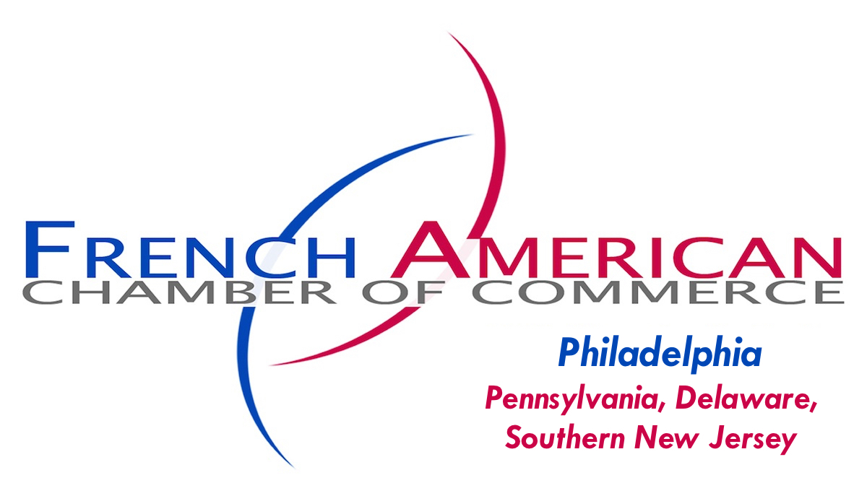
Judith Ujobai, Executive Director
French-American Chamber of Commerce
215-716-1996
info@FACCphila.org
www.FACCphila.org

Beaujolais Nouveau Rises to New Heights with
The French-American Chamber of Commerce & One Liberty Observation Deck!

Philadelphia, Pennsylvania, USA — November 14, 2016 -- A longstanding French-Philadelphia tradition, the uncorking of the Beaujolais Nouveau, rises to new heights thanks to the partnership between the French-American Chamber of Commerce and One Liberty Observation Deck, host of the 26th Annual Savor Wine Festival & Business Networking Reception. Over 150 FACC Members and guests are expected to attend the event on Thursday, November 17th, 2016, 6:00 PM to 8:00 PM, at One Liberty Observation Deck, 1650 Market Street, 57th Floor, Philadelphia, PA 19103.

“It's a great fit for One Liberty Observation Deck which is owned and operated by Montparnasse 56, a French global tourism company known for its spectacular attractions in Paris, the South of France, Chicago and Berlin," said Evan G. Evans, General Manager, and FACC Ambassador Member.

The FACC's Savor Wine Festival features the first uncorking of Georges Duboeuf's 2016 Beaujolais Nouveau, courtesy of Quintessential Wines, and tastings of wines from around the world selected by Boutique Wine Collection, Majestic Wine & Spirits, Descheres Wine & Spirits, and Moore Brothers Wine Company. International gourmet fare will be provided by DiBruno Bros. The evening culminates with a Business Card Drawing for prizes, including two pairs of tickets to see the touring company of the award-winning Broadway Show, An American in Paris, at the Academy of Music from the Kimmel Center Presents.
Corporate Sponsors of the FACC's Fall Fundraiser include Fox Rothschild, WeiserMazars Consulting,
BDP International, Arkema, Duane Morris, and Green and Spiegel and KPMG. Proceeds from this event help sustain the organization's mission to promote trade with France and economic development in Pennsylvania, Delaware and Southern New Jersey. The FACC provides a forum for the interests of its members, French and American-Francophile business leaders motivated to pursue new business opportunities through networking, stronger cross-cultural relations and enduring friendships.

Registration for the 11/17 Savor Wine Festival is $75/person for the General Public at www.FACCphila.org, but don't delay, as space is limited and this event is likely to sell out before the 11/16 Payment Deadline. Tickets will also be available at the door for $84 ($19 at the Cashier for admission to the Observation Deck and $65 at the FACC Registration Table to participate in the Savor Wine Festival).

For Corporate Sponsorship Opportunities, click on the link on our website or contact info@FACCphila.org. The FACC looks forward to warmly welcoming you and your guests to the Savor Wine Festival at the One Liberty Observation Deck where we will celebrate the 2016 French grape harvest and toast to Philadelphia's thriving French-American business community!

Starting the third Thursday in November, 19 FACC Chapters will debut France's world-renowned Beaujolais Nouveau traditions at wine festival fundraisers in major cities across the nation. Visit www.FACCWineFestivals.com for information about an event near you.

Founded in 1989, the Philadelphia Chapter of the French-American Chamber of Commerce is a 300-Member strong, non-profit business association that ranks among the largest and most dynamic of 12 Bi-national Chambers of Commerce in the Delaware Valley. In addition to its affiliation with the 20-Chapter FACC National Network with 4,000 Members, the FACC Philadelphia is a member of CCI France International which comprises 115 French Chambers of Commerce and Industry in 85 countries and 25,000 Member Companies.
###

